Course Notes

Course meet times:

1. Every Tues: duration 1 hr 15 min.

-meet for open discussions of current topics

2. Due date for final project phase -> 4.26 Thurs.

3. No final exam will be issued

Topics covered

Frameworks / Api’s

1) JSP pages (expressions, scriplets, declarations)

See code syntax / logic below

2) JDBC (MYSQL connectivity with Hibernate)

3) Tomcat

Hibernate exclusive

1) Annotations -> Data Mapping

2) SessionFactory/objects

3) DDL statements

Demos:

1. Working hibernate

Gen. Housekeeping:

-Create Java project

-Open Hibernate project files (download release)

For [JDBC](https://docs.jboss.org/hibernate/orm/3.3/reference/en-US/html/session-configuration.html) hibernate.cfg.xml file, check **project->bin** folder for hibernate.cfg.xml (ex. mysl jdbc)

(set up params for localhost or just point to papaserver…)

For library dependencies, open hibernate **project folder->lib->required**.

Copy all files into **project\lib** folder. Include these in build path as required library (jars)

Folder view

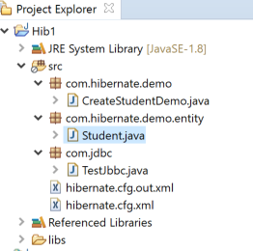

Make sure to place hibernate config file in root of proj. See attached zip files of hibernate proj.

Check attached zip file of hibernate project.

2. JSP file processing

Housekeeping:

Create Dynamic Web Project

Tree

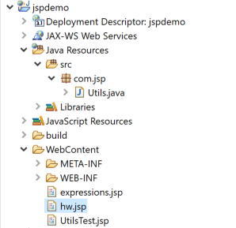

Incl. Java file for supportive functions in Java Resources folder

Create expressions, servlets, declarations on java functions

See attached zip files on jspdemo.

3. Working WebService – Client / Server socket connections

Housekeeping:

Create Dynamic Web Project

Run Server file as Java Application then..

Run Client file as Java Application

See attached zip files on WebSockets.

Note possible Socket *connection* issues

Killing off pid (useful commands)- if error occurs. Example

Exception in thread "main" java.net.BindException: Address already in use: JVM_Bind

Solution kill running port by pid

**Win.**

netstat -ano

taskkill -pid 15260 /f

**Linux/Mac**

If you know what port the process is running you can type: lsof -i:<port>.

For instance, lsof -i:8080, to list the process (pid) running on port 8080.

Then kill the process with kill <pid>

Ex. lsof command (mac)

COMMAND PID USER FD TYPE DEVICE SIZE/OFF NODE NAME

LogiVCCor 1327 imac 8u IPv4 0xa4bf093b7f7c7ebf 0t0 TCP 10.0.1.9:**49204**->52.94.29.20:https (CLOSED)

Mail 1435 imac 28u IPv4 0xa4bf0c880f 0t0 TCP 10.0.1.9:**49206**->74.125.124.109:imaps (ESTABLISHED)

Next week topical coverage

Connecting HTML files with JSP files

Client / Server socket connections over http

Maven dependencies

Servlets

JSF

SOAP services